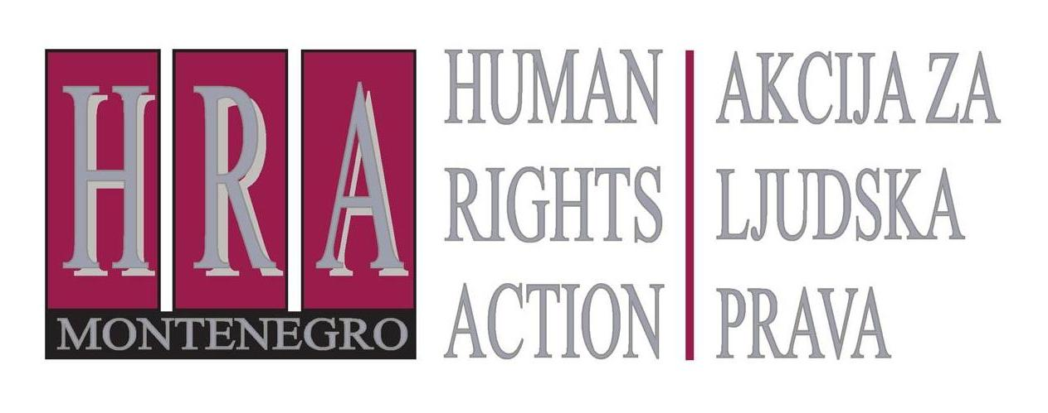

Ulica Slobode 74/ II, 81 000 Podgorica, Crna Gora T/F: +382 20 232 348/ +382 20 232 358; +382 20 232 122
E-mail: hra@t-com.me www.hraction.org

Hotel Ramada, Podgorica, Montenegro
Mr. Tanju Özalpay, Executive Director
Mr. Omer Dogru, owner of Gintasmont
Podgorica, 12 August 2016

Dear Mr. Özalpay, Mr. Dogru,

I would firstly like to greet You and inform You that NGO Human Rights Action has organized several seminars in 2016 and 2015 at Ramada Hotel. We were very satisfied with the conditions provided as well as with highly professional cooperation with all Your friendly staff members.

I am addressing You with regard to Your decision not to extend the employment contract to Sales & Marketing Director Patricia Pobrić immediately after she had contributed to informing the public about serious allegations involving misuse of state resources for political party purposes. This information has in the meantime resulted in initiation of criminal proceedings indicating that public funds were indeed misused.

According to HRA information, Ms. Pobrić was an exemplary employee whose contract would have been extended had she not decided to act in public interest. We conclude with regret that by terminating cooperation with Ms. Pobrić due to her honorable action, the hotel management proved unwilling to support human rights values.

HRA also finds that such treatment on Your part is contrary to 2007 Human Rights Policy Statement, adopted by the Wyndham Worldwide Group including Ramada Hotels, which reflects the commitment of the Wyndham Worldwide to protect human rights of its employees, ethical business practices and good corporate citizenship, as well as create safe and healthy working environment that values and respects its personnel. In this case, Ms. Pobrić was punished rather than being rewarded for her success in sales and marketing at Ramada Hotel as well as for performance in public interest.

We kindly ask You to reconsider Your position and extend an apology to Ms. Pobrić, invite her her to collaborate again with Ramada Hotel and encourage all other employees to report suspected corruption in public interest. Otherwise, HRA as human rights organization may no longer continue to be Your client and advocate human rights under the roof of a hotel treating its employees who dare protect the rule of law in such an unjust manner.

Sincerely,

________________________
Tea Gorjanc Prelević
Executive Director of NGO Human Rights Action

