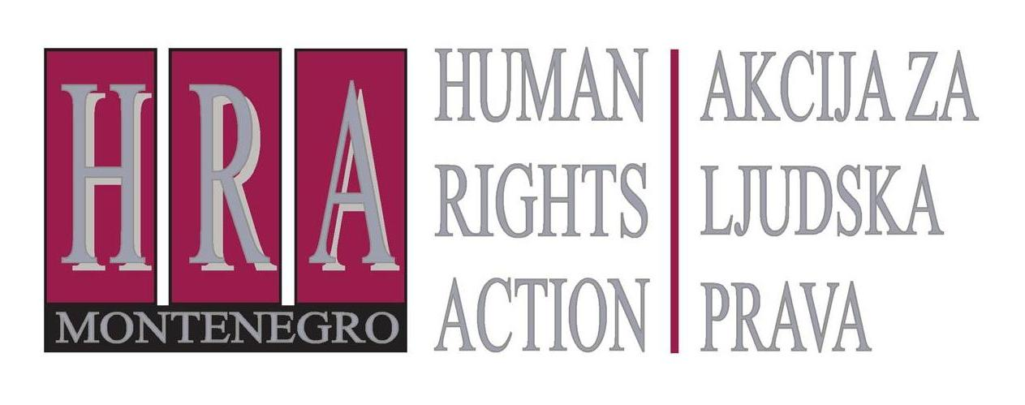

European Court of Human Rights judgments on the right to freedom of expression

Bulletin XXIII: ON THE LIABILITY OF INTERNET PORTALS FOR THE PUBLICATION OF OFFENSIVE COMMENTS: THE IMPLICATIONS OF THE ECTHR JUDGEMENT IN DELFI V. ESTONIA
24 October 2013
D
uring September 2013, the European Court adopted judgments and decisions in the following freedom of expression case:
- Delfi v. Estonia (Application no. 64569/09), 10 October 2013: internet news site liable for comments that were posted by users
This case concerned the question to what extent an internet news site is responsible and can be held liable for offensive comments left on the site by users. The applicant, Delfi AS, is a company that owns one of the largest internet news sites in Estonia. In January 2006, it published an article about a ferry company which had changed its route to certain islands. This had broken up sea ice, as a result of which winter ice roads, which are a cheaper and faster connection to the islands compared to the ferries, could not be opened. Below the article, many readers had left highly offensive or threatening comments about the ferry company.
The ferry company sent a letter to Delfi demanding the removal of the offensive comments. Delfi removed the comments immediately on receipt of the letter. The ferry company then sued and obtained a judgment which found that the comments were defamatory, and that Delfi was responsible for them. The ferry company was awarded 5,000 kroons in damages (around 320 euros). Delfi appealed arguing that under EU law (in particular, EU Directive 2000/31/EC on Electronic Commerce) it should not be held liable for the comments since it did not control them. The Estonian Supreme Court disagreed and found that Delfi was to be considered as the ‘publisher’ of the comments and should have exercised control over them.
Delfi then appealed to the European Court of Human Rights claiming that to hold them liable for comments left by their users violated their right to freedom of expression.
In considering whether the finding of defamation violated the right to freedom of expression, the Court declined to consider the question of liability under European Union law, saying that it was for the domestic courts to resolve issues of interpretation of domestic law with EU law. The Court merely stated that the national courts had relied on the Estonian civil code to find Delfi liable. This meant that defamation judgment had been lawful and complied with the “prescribed by law” requirement under the Convention.
Furthermore, the Court noted that interferences with the right to freedom of expression are legitimate under the European Convention on Human Rights as long as the interference is “proportionate” and “necessary” in a democratic society. In assessing whether the interference had been “proportionate”, the Court considered four issues.
First, the Court noted that the comments on the Delfi website had been clearly insulting, threatening and defamatory in nature. The Court held that Delfi should have expected this: despite the fact that the original article was balanced and contained no offensive language, the topic of the article had been very likely to lead to emotional reactions from its readers and Delfi should have exercised an extra degree of caution; they should have checked the comments proactively and removed any that were likely to be defamatory or otherwise illegal.
Second, the Court noted that Delfi had done very little to prevent the publication of defamatory comments on its website. Its news website, and the article in question, did state that the authors of comments would be liable for their content and that threatening or insulting comments were not allowed. The website also automatically deleted posts that contained certain vulgar words, and users could warn the administrators of the site about offensive comments by clicking a button upon which administrators would remove the content. However, despite this, a large number of offensive and insulting comments were still left underneath the article.
Third, in answer to the Delfi’s argument that the ferry company should have sued for defamation the authors of comments instead, the Court noted that it would have been extremely difficult for the ferry company to establish the identity of the authors of specific insulting comments because readers were allowed to leave comments anonymously. The Court considered that it was therefore both practical to hold Delfi liable, as well as reasonable, because Delfi profited financially from articles that attracted a high readership.
Fourth, the Court noted that the award made against Delfi had been relatively small - €320 – and that no other orders limiting freedom of expression had been made against the company.
Taking all four of these points into account, the Court held that the defamation award against Delfi did not violate the right to freedom of expression.
Comment:
This is the first judgment of the European Court of Human Rights dealing with liability for user generated content and reader comments on a news website. The applicant, Delfi, is expected to request a referral to the Grand Chamber of the Court (which has the power to hear a limited number of appeals) asking whether it is sufficient for a website to remove offensive comments only after they have received a complaint regarding these comments, or whether they should be expected to proactively monitor their site and remove comments which they think might be defamatory or otherwise unlawful. A key question is the relationship with European Union law, which suggests a different standard from that set by the Strasbourg court. Under European Union legislation (particularly, EU Directive 2000/31) the liability of news websites that ‘host’ comments is limited if they remove illegal comments as soon as possible after they are notified of their defamatory or otherwise illegal nature. Delfi expected that it was exempted from liability as it had removed the offensive comments upon receipt of a complaint, in accordance with the EU standard.

Prepared by Peter Noorlander, Director of Media Legal Defence Initiative, London in cooperation with HRA


Bulletins are published within the project “Monitoring of Journalistic Self-Regulatory Bodies in Montenegro” funded by the British Embassy Podgorica.

