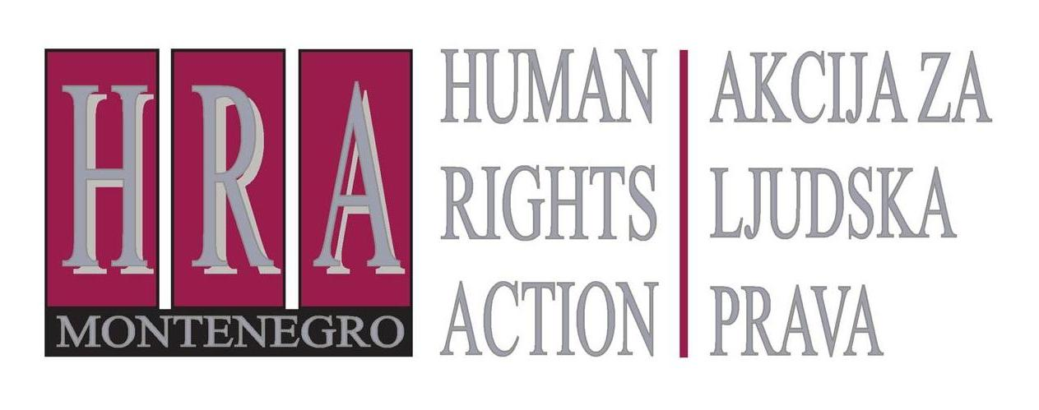

European Court of Human Rights judgments on the right to freedom of expression

Bulletin XV: ROUND-UP OF JUDGEMENTS FROM MARCH 2013
26 April 2013
D
uring March 2013, the European Court adopted judgments in the following media freedom and freedom of expression cases:
- Kasymakhunov and Saybatalov v. Russia (nos. 26261/05 and 26377/06), 14 March 2013 (conviction for membership of a religious organisation deemed to be ‘terrorist’ did not violate rights to freedom of expression, association or religion)
- Eon v. France (no. 26118/10) 14 March 2013 (conviction for insulting the French president violated the right to freedom of expression)
- Niculescu-Dellakeza v. Romania (no. 5393/04) 26 March 2013 (conviction for defamation violated the right to freedom of expression); and
- Novaya Gazeta and Borodyanskiy v. Russia (no. 14087/08), 28 March 2013 (defamation conviction over allegations of fraud did not violate the right to freedom of expression)
The judgments concerned the following issues.
- Kasymakhunov and Saybatalov v. Russia (nos. 26261/05 and 26377/06), 14 March 2013 (conviction for membership of a religious organisation deemed to be ‘terrorist’ did not violate rights to freedom of expression, association or religion)
The applicants in this case had been convicted for their membership of the religious group, Hizb ut-Tahrir, and complained that this violated their rights to freedom of religion, freedom of expression and freedom of association. The Court held that the application constituted an ‘abuse of rights’ under Article 17 and held the conviction therefore did not violate the rights to freedom of religion, expression or association. The Court considered that political and/or religious organisations must act within certain limits. In particular, a political or religious party or organisation may promote a change in the law or the legal and constitutional structures of the State only on two conditions: (1) the means used to that end must be legal and democratic; (2) the change proposed must itself be compatible with fundamental democratic principles. Therefore, a political organisation whose leaders incite to violence or put forward a policy which fails to respect democracy or which is aimed at the destruction of democracy and human rights cannot claim the protection of Convention rights. The Court held that the ideology and activities of Hizb ut-Tahrir failed these tests.

- Eon v. France (no. 26118/10) 14 March 2013 (conviction for insulting the French president violated the right to freedom of expression)
This concerned a socialist who had waved a placard reading “Casse toi pov’con” (“Get lost, you sad prick”) during a presidential visit to his region. The phrase had been spoken by the president himself several months previously when a farmer had refused to shake his hand. The applicant was immediately arrested, prosecuted and convicted for insulting the president. The applicant complained that his conviction breached the right to freedom of expression. The European Court agreed, stating that while the phrase would be considered offensive to the president, it was clearly a satirical remark. The president himself had used the same words against a farmer only months previously. To criminalise such a remark would have a deterrent effect on satire as well as on free debate questions of general interest. The conviction was therefore not ‘necessary in a democratic society’.
- Niculescu-Dellakeza v. Romania (no. 5393/04) 26 March 2013 (conviction for defamation violated the right to freedom of expression)
This concerned a man who, during a television programme, had called the director of a theatre a “seven-handed stage director” and had then published an open letter to him in the local paper accusing him of holding several posts simultaneously and misappropriating public funds. The theatre director sued for defamation and the applicant was sentenced to a fine and payment of compensation and costs. The European Court of Human Rights held that this conviction violated the right to freedom of expression. It stressed that the theatre concerned was a public institution, and that the allegations had been a mix of value judgments (for example, calling him ‘seven handed’) and statements of fact. The primary aim of the applicant had been to contribute to a debate on an issue of general interest, not to insult the director, and the allegations had been within the limits of allowable exaggeration or provocation. The Court finally took into account that the fine had been substantial (€1,100) and the proceedings against the applicant had been of a criminal nature. Taking all these considerations into account the Court held that the conviction constituted a violation of the right to freedom of expression.

- Novaya Gazeta and Borodyanskiy v. Russia (no. 14087/08), 28 March 2013 (defamation conviction over allegations of fraud did not violate the right to freedom of expression)
This concerned the publisher of a Russian newspaper and one of its journalists, who had been convicted of defamation for an article describing fraudulent schemes that had been used to obtain large bank loans. The article mentioned various individuals and one of them, a governor, sued in defamation over allegations that he had provided commercial and political favours to a Kazakh businessman. He was awarded damages of €1,800 and the newspaper was ordered to print a retraction. The newspaper complained to the European Court of Human Rights which held that the conviction did not violate the right to freedom of expression. The Court stated that while the article dealt with a matter of significant public interest, concerned a prominent politician and a certain degree of journalistic exaggeration and provocation had to be tolerated, the journalist and newspaper had not attempted to provide any proof whatsoever for their allegations. Therefore, the conviction did not violate the right to freedom of expression.

Prepared by Peter Noorlander, Director of Media Legal Defence Initiative, London in cooperation with HRA


Bulletins are published within the project “Monitoring of Journalistic Self-Regulatory Bodies in Montenegro” funded by the British Embassy Podgorica.

