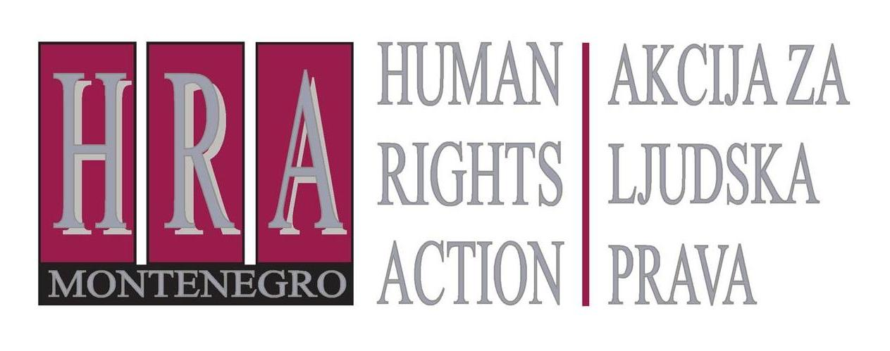

European Court of Human Rights judgments on the right to freedom of expression

Bulletin XIV: ECHR AND DAMAGE AWARDS IN DEFAMATION AND PRIVACY CASES
24 April 2013

The European Court of Human Rights has held that disproportionate awards of damages in defamation and privacy cases can violate the right to freedom of expression – even if what the media wrote was untrue and defamatory. Not only must there be a relationship of proportionality between the damage done by the defamatory remarks and the damages awarded, the court must also have regard to the impact of the award on the journalist or media outlet concerned. Finally, the court must take into account the wider ‘chilling effect’ of the damage award on the media. The European Court of Human Rights requires that rules relating to damages are clearly stated in domestic law.
The Committee of Ministers has affirmed these principles in its 2004 Declaration on freedom of political debate in the media.
The following judgments indicate how the European Court applies these general principles.

European Court of Human Rights decisions
- Tolstoy Miloslavsky v. the United Kingdom (no. 18139/91, 13 July 1995) (disproportionate defamation award, three times bigger than any award previously made, violated the right to freedom of expression)
This concerned a historian who had published a pamphlet accusing Lord Aldington of war crimes. Lord Aldington sued for libel and was awarded £1,500,000 in damages. This sum was three times greater than the largest amount previously awarded in a libel case. The European Court of Human Rights held that although the accusation was very grave, the amount of damages violated the right to freedom of expression of the historian. It stated that, as a rule, “an award of damages for defamation must bear a reasonable relationship of proportionality to the injury to reputation suffered.” It noted that English law at the time did not require for such proportionality, nor did it provide for any safeguards to keep defamation awards within reasonable limits.
- Steel and Morris v. the United Kingdom (no. 68416/01, 15 May 2005) (defamation award was disproportionate when compared to the income of the defendants)
This concerned two individuals who had written and distributed a leaflet entitled “What’s wrong with McDonald’s?”, which was critical of the fast food chain. McDonalds sued for defamation and won, after very long proceedings, damages of £40,000. McDonalds did not enforce the award and did not apply to have its legal costs, which were substantial, paid. The European Court of Human Rights considered the case and noted that the two earned very low incomes and had not been represented by lawyers. The Court concluded that this had placed the two at a considerable disadvantage, and that “[while the damages awarded were] relatively moderate by contemporary standards [they were] very substantial when compared to the modest incomes and resources of the ... applicants”. The award of damages therefore constituted a violation of the right to freedom of expression.
- Koprivica v. Montenegro (no. 41158/09, 22 November 2011) (defamation award that was to be paid off in instalments each equalling half the applicant’s pension violated the right to freedom of expression)
This concerned a complaint brought by the editor of a magazine, who had been convicted for defamation for an article which had reported, in 1994, that a number of journalists were to be tried for war crimes. The editor was ordered to pay €5,000, together with the magazine’s publisher, which was to be paid in regular payments each of which amounted to half his pension. The European Court of Human Rights found that this violated the right to freedom of expression, stating that “the damages and costs awarded were very substantial when compared to the applicant’s income at the time, being roughly twenty-five times greater than the applicant’s pension[and were] very substantial even when compared to the highest incomes in the respondent State in general”.
- Filipovic v. Serbia (no. 27935/05, 20 November 2007) (defamation order totalling six months’ salary was disproportionate and violated the right to freedom of expression)
This concerned a tax inspector who, at a public meeting, had alleged that a local mayor had embezzled public funds. He was found guilty of defamation and ordered to pay damages of 120,000 Serbian Dinars, which equalled six months’ of his salary. The European Court held that this violated his right to freedom of expression, stating that the order had not been necessary in a democratic society.
- MGN Limited v. the United Kingdom (no. 39401/04, 12 June 2012) (order to pay legal fees as well as ‘success fee’ of more than £1m to claimant in privacy case violated right to freedom of expression)
This concerned a case of invasion of privacy brought by a model against a newspaper, for the publication of photographs that showed her outside a drug treatment centre. The newspaper had lost the privacy case and had been ordered to pay £3,500 in damages, as well as legal costs totalling more than £1m. The European Court held that this violated the right to freedom of expression, stating that “the requirement that the applicant pay success fees to the claimant was disproportionate having regard to the legitimate aims sought to be achieved and exceeded even the broad margin of appreciation accorded to the Government in such matters.”
- Krone Verlag GmbH v. Austria (no. 27306/07), 19 June 2012 (order that a newspaper company pay €130,000 in damages for intrusion of privacy did not violate the right to freedom of expression)
This concerned compensation proceedings brought by another and child against two publishing companies for their newspapers’ reports on the dispute between the parents over custody. The reports revealed the child’s identity and showed photographs from which he could be recognised, and were found to constitute an interference with the child’s right to respect for his private life. The applicant was ordered to pay €130,000 in damages, in respect of a series of 13 articles, and complained to the European Court of Human Rights that this was disproportionate and violated the right to freedom of expression. The Court held that it did not. It stated that the amount was in line with domestic law, which explicitly required that damages should not endanger the economic existence of the media owner. The Court held that this constituted a sufficient safeguard and that the amount ordered was not disproportionate in the particular circumstances of the case.
- Independent News and Media and Independent Newspapers v. Ireland (no. 55120/00,16 June 2005) (order to pay €381,000 in defamation damages did not violate right to freedom of expression taking into account safeguards in domestic law)
This concerned an application brought by a newspaper company which had been convicted of defamation and ordered to pay €381,000, an award which was three times higher than any previous award for defamation made in Ireland. The European Court considered that this did not violate the right to freedom of expression. It noted that “as matter of principle, unpredictably large damages’ awards in libel cases are considered capable of having [a chilling effect on the press] and therefore require the most careful scrutiny”. However, bearing in mind that the libel was serious and grave, and noting that appeal courts had considered the amount to be proportionate, the Court held that the order did not violate the right to freedom of expression.

Recommendations by international organisations
The Declaration on freedom of political debate in the media, adopted in 2004 by the Committee of Ministers of the Council of Europe (click here for the English version and http://www.coe.int/t/dghl/standardsetting/media/Doc/Translations/Montenegrin/Dec(2004)PoliticalDebate_mn.pdf for a translation in Montenegrin) states, under VIII:
Remedies against violations by the media
Damages and fines for defamation or insult must bear a reasonable relationship of proportionality to the violation of the rights or reputation of others, taking into consideration any possible effective and adequate voluntary remedies that have been granted by the media and accepted by the persons concerned.

Prepared by Peter Noorlander, Director of Media Law Defence Initiative, London in cooperation with HRA

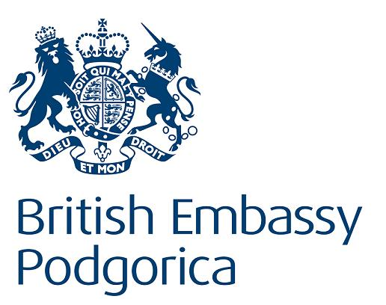
Bulletins are published within the project “Monitoring of Journalistic Self-Regulatory Bodies in Montenegro” funded by the British Embassy Podgorica.

