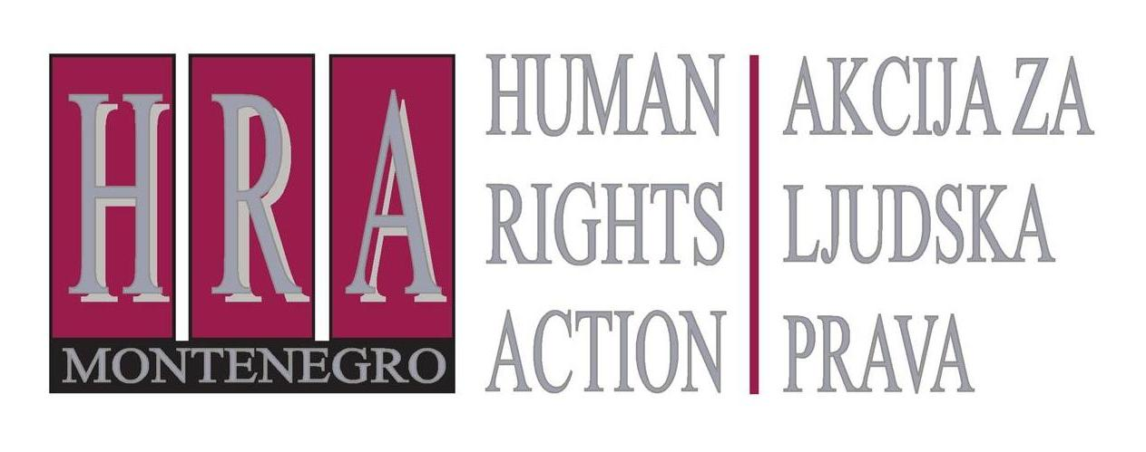

European Court of Human Rights judgments on the right to freedom of expression

Bulletin XIII: ROUND-UP OF JUDGEMENTS FROM FEBRUARY 2013
24 April 2013
D
uring February 2013, the European Court adopted judgments in only one media freedom case:
- Bugan v. Romania (no. no. 13824/06), 12 February 2013
(defamation conviction of journalist for harsh criticism of functioning of hospital director violated freedom of expression)
This concerned an application by a journalist who had been ordered to pay damages to the director of a public hospital because of an article he had written complaining about the director’s management, his alleged intimidation of the hospital’s doctors, the closure of the intensive care department, and the director’s attempts to obtain social housing despite not meeting the requirements. Some of the articles included derogatory terms and remarks, including allegations that the director had “pulled many strings to become director” and “aspired to the title of the most dreadful social climber”. The director sued for defamation and won a judgment awarding him damages and legal costs.
The Court found that the conviction constituted a violation of the journalist’s right to freedom of expression. It considered that the statements made concerned political issues and other matters of general interest, and that public officials – including hospital directors – should tolerate criticism of their functioning. It considered furthermore that freedom of expression is also applicable to “information” or “ideas” that offend, shock or disturb. While some of the journalist’s comments referred to the victim’s private life, the overall language remained within the acceptable limits of journalistic freedom. It noted finally that the courts had not given a reasoned decision justifying the defamation conviction.

Related publications
Readers of this bulletin may find a recent study published by the Council of Europe’s research division of interest, on “The alignment of laws and practices concerning defamation with the relevant case-law of the European Court of Human Rights on freedom of expression, particularly with regard to the principle of proportionality”
(http://www.coe.int/t/dghl/standardsetting/media/CDMSI/CDMSI(2012)Misc11Rev2_en.pdf). This study investigates, among other things, the case-law of the European Court of Human Rights on freedom of expression in the context of defamation cases and reviews Council of Europe and other international standards on defamation. It contains information on the legal provisions on defamation in various Council of Europe member states. It also attempts to identify trends in the development of rules on defamation, both in national legal systems and in international law.

Prepared by Peter Noorlander, Director of Media Law Defence Initiative, London in cooperation with HRA

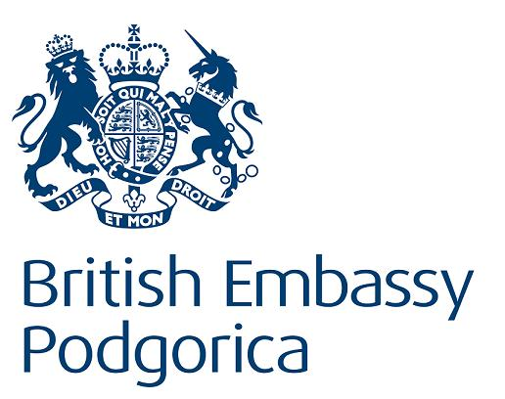
Bulletins are published within the project “Monitoring of Journalistic Self-Regulatory Bodies in Montenegro” funded by the British Embassy Podgorica.

