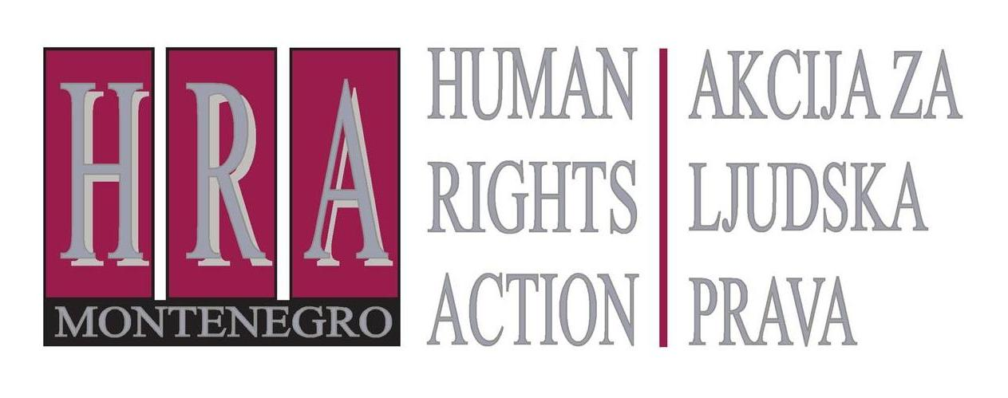

European Court of Human Rights judgments on the right to freedom of expression

Bulletin X: FREEDOM OF EXPRESSION AND HATE SPEECH
19 February 2013

The European Court of Human Rights has identified several categories of speech which are considered to be offensive to the concept of human rights and are therefore not protected by the right to freedom of expression. This kind of speech is often referred to as “hate speech”.
The mere use of language that is deemed insulting or that is offensive is not considered ‘hate speech’. ‘Hate speech’ is only classified as such if it undermines fundamental norms of human rights and democracy, or if it incites hatred or violence against a group.
The Court has not formulated an all-encompassing definition of “hate speech”, preferring instead to leave the definition open. It has identified as “hate speech” speech that aims to stir up racial or ethnic hatred (as illustrated by its decisions in Féret v. Belgium and, as regards the specific issue of holocaust denial, Garaudy v. France); speech that incites hatred against individuals on grounds of their sexual orientation (illustrated by its decision in Vejdeland and others v. Sweden); religion (as illustrated by the Court’s decision in Norwood v. the United Kingdom). The Court has also dealt with a number of cases concerning speech that denied fundamental values of democracy and tolerance; it will generally reject any applications which are inspired by totalitarian or anti-democratic doctrine(best illustrated by the decision in Refah Partisi (The Welfare Party) and Others v. Turkey).
At the same time, whilst recognising that “hate speech” exists and denying it the protection of Article 10 of the European Convention of Human Rights, the Court has been very careful to distinguish between what it considers legitimate political speech and hate speech (see for example Association of Citizens “Radko” & Paunkovski v. the former Yugoslav Republic of Macedonia), and it has also allowed journalists to report on hate speech (as illustrated by its decision in Jersild v. Denmark).
The Committee of Ministers of the Council of Europe has adopted a recommendation on the topic of hate speech which elaborates on the Court’s jurisprudence.
The following paragraphs summarise the Court’s main decisions in this area as well as the Council of Europe’s recommendations.

European Court of Human Rights decisions

- Féret v. Belgium, Application No. 15615/07, 16 July 2009 (inciting hatred against immigrants and on grounds of religion not protected by right to freedom of expression)
This concerned an application to the Court by a Belgian politician and member of parliament who had been convicted for distributing election leaflets that carried the slogans, “Stand up against the Islamification of Belgium”, “Stop the sham integration policy” and “Send non-European job-seekers home”. He was sentenced to community service and disqualified from being a member of parliament for ten years. The Court held that this did not constitute a violation of his right to freedom expression: the politician’s comments had been clearly likely to incite hatred against foreigners, particularly in the heightened political context of elections. The conviction could therefore be considered as “necessary” to prevent public disorder and to prevent the rights of others, namely members of the immigrant community.
- Garaudy v. France, application no. 65831/01, 24 June 2003 (holocaust denial not protected by the right to freedom of expression)
This concerned a French author who had written and published a book entitled “The Founding Myths of Modern Israel”, in which he disputed the extent of the holocaust. He was convicted for ‘holocaust’ denial’, a crime under French law, defamation of the Jews and incitement to racial hatred; and appealed to the European Court of Human Rights arguing that his right to freedom of expression had been violated.
The Court held that the conviction did not violate the right to freedom of expression. It considered that “[denying] crimes against humanity [was] one of the most serious forms of racial defamation of Jews and of incitement to hatred of them”. It also held that disputing the existence of clearly established historical events such as the holocaust did not constitute scientific or historical research, and that its clear purpose was instead to rehabilitate the Nazi regime and accuse the victims of falsifying history. This was incompatible with fundamental values underlying the European Convention on Human Rights and was not therefore protected under the right to freedom of expression.
- Vejdeland and others v. Sweden, application no. 1813/07, 9 February 2012 (hate speech towards homosexuals not protected under right to freedom of expression)
This concerned the conviction of the applicants for distributing leaflets in a school alleging that homosexuality was a “deviant sexual proclivity”, had “a morally destructive effect on the substance of society” and was responsible for the development of HIV and AIDS. The leaflets were considered to be offensive to homosexuals and the applicants were convicted. The applicants appealed to the European Court arguing that they had not intended to express contempt for homosexuals as a group, but that they had sought to start a debate about the lack of objectivity in the education in Swedish schools.
The Court held that the applicants’ conviction did not violate their right to freedom of expression. It considered that the allegations in the leaflets had constituted serious and prejudicial allegations, and that that discrimination based on sexual orientation was as serious as discrimination based on “race, origin or colour”. Even though the statements did not constitute a direct call to hatred or hateful acts, the conviction could be reasonably regarded as “necessary” in a democratic society for the protection of the reputation and rights of others.
- Norwood v. the United Kingdom, application no. 23131/03, 16 November 2004 (inciting hatred on grounds of religion not protected under right to freedom of expression)
The applicant had displayed a poster by a rightwing political party, showing the Twin Towers in New York in flame accompanied by the text “Islam out of Britain – Protect the British People”. He was convicted of aggravated hostility towards a religious group and argued that this conviction violated his right to freedom of expression. The Court declared the case inadmissible, holding that no issues were raised under Article 10: such a general, vehement attack against a religious group, linking the group as a whole with a grave act of terrorism, was incompatible with the values proclaimed and guaranteed by the Convention, notably tolerance, social peace and non-discrimination.
- Refah Partisi (The Welfare Party) and Others v. Turkey, application nos. 41340/98, 41342/98, 41343/98 and 41344/98), 13 February 2003 (advocacy for anti-democratic concepts not protected under the right to freedom of expression)
This concerned an application by a political party which had been dissolved on the grounds that it had become a “centre of activities against the principle of secularism”. Amongst its goals and objectives, the party sought the introduction of strict Islamic law and the establishment of a theocratic regime. Several of the parties members complained to the European Court of Human Rights, arguing that their right to freedom of expression and association had been violated.
The European Court considered that the party’s acts and speeches by its leaders revealed that its long-term policy was the establishment of a political regime of Sharia law that was not compatible with fundamental values underlying the Convention, and that it did not exclude recourse to force. This presented an immediate danger to democracy and meant that the party’s dissolution could be justified as “necessary” in a democratic society. There had been no violation of the right to freedom of expression and the right to freedom of association.
- Association of Citizens “Radko” & Paunkovski v. the former Yugoslav Republic of Macedonia, application no. 74651/01, 15 January 2009 (dissolving an association whose name was associated with fascism violated the rights to freedom of association and expression)
This concerned the dissolution of a citizens’ association that had been named after the leader of the Macedonian Liberation Movement for over 60 years. The authorities considered that the name of the movement promoted fascist ideas concerning the Bulgarian origins of the Macedonian people, negated the identity of the Macedonian people and encouraged national or religious hatred and intolerance.
The Court held that the dissolution of the association violated the group’s rights to freedom of association and expression. The mere fact of naming the association after an individual who was perceived negatively by the majority of the population did not by itself be considered a present and imminent threat to public order. The association had not advocated hostility nor did it intend to use violence. While the Court acknowledged that the association’s interpretation of national history was liable to shock people, this did not amount to an attack on fundamental values and rules of democracy.
- Jersild v. Denmark, application no. 15890/89, 23 September 1994b (right of journalists to report on hate speech)
This concerned a journalist who had made a documentary that included extracts from a television interview he had conducted with three members of a racist group. These three had made abusive and derogatory remarks about immigrants and ethnic groups, and the journalist was convicted for assisting in the dissemination of racist remarks. He complained to the Court arguing that the conviction violated his right to freedom of expression.
The Court held that the conviction did violate his right to freedom of expression. It drew a distinction between the three racist youth, who had made racist remarks, and the journalist, who had reported the remarks. It considered furthermore that the journalist’s aim had been to expose racism, and analyse and explain racist attitudes. This was a matter of great public concern which the public had a right to be informed on. The Court also considered that, taken as a whole, the documentary had clearly not been aimed at propagating racist views and ideas.

Council of Europe Recommendations

- Recommendation No. R 97(20) of the Committee of Ministers of the Council of Europe on “hate speech”
This Recommendation by the Committee of Ministers requires States to legislate against hate speech, as well as to refrain from hate speech themselves.
The Recommendation defines hate speech as “covering all forms of expression which spread, incite, promote or justify racial hatred, xenophobia, antisemitism or other forms of hatred based on intolerance, including: intolerance expressed by aggressive nationalism and ethnocentrism, discrimination and hostility against minorities, migrants and people of immigrant origin.”
Principle 1 states that “governments of the member states, public authorities and public institutions at the national, regional and local levels, as well as officials, have a special responsibility to refrain from statements, in particular to the media, which may reasonably be understood as hate speech”.
Principle 2 requires that States “establish or maintain a sound legal framework consisting of civil, criminal and administrative law provisions on hate speech.” Under Principle 3, any “interferences with freedom of expression [should be] narrowly circumscribed and applied in a lawful and non-arbitrary manner on the basis of objective criteria”. Principle 7 stipulates that “reporting on racism, xenophobia, antisemitism or other forms of intolerance is fully protected by Article 10”.
Prepared by Peter Noorlander, Director of Media Law Defence Initiative, London in cooperation with HRA

Bulletins are published within the project “Monitoring of Journalistic Self-Regulatory Bodies in Montenegro” funded by the British Embassy Podgorica.

