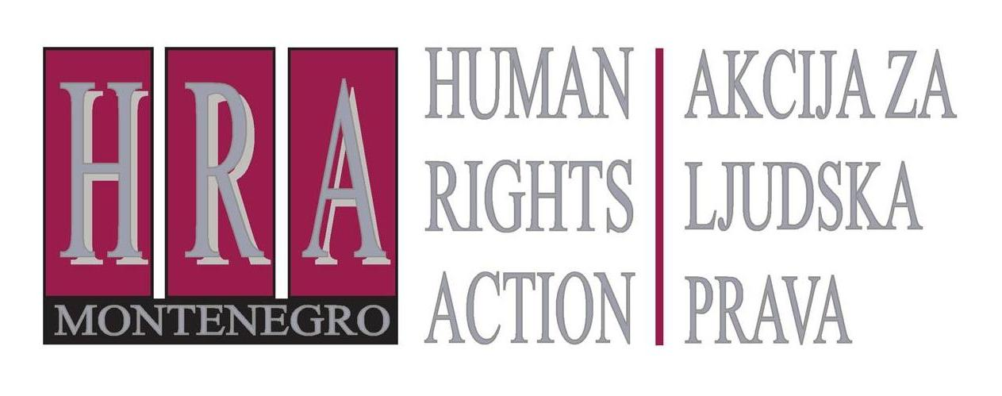

European Court of Human Rights judgments on the right to freedom of expression

Bulletin VII: ACCESS TO INFORMATION
26 December 2012

The right of access to information under Article 10 ECHR and other international law

The European Court has held that access to information is a protected right under the Convention if the information requested is necessary for the fulfilment of another protected right. For journalists, whose day-to-day job entails the exercise of the right to freedom of expression, this means that they have a right of access to the information needed for their reporting.
The European Court’s leading judgments on this are the following:
- Kenedi v. Hungary, application no. 31475/05, judgment 26 May 2009
- Társaság a Szabadságjogokért v. Hungary, no. 37374/05, judgment 14 April 2009
It should be noted that these judgments concern the right to information held by public bodies other than private information. Access to such information is protected as part of the right to respect for private life, under Article 8 of the Convention.
The UN Human Rights Committee, the body of independent experts that monitors implementation of the International Covenant on Civil and Political Rights (ICCPR, which Montenegro has ratified) has adopted a broader interpretation of the right of access to information, holding that such a right is protected per se under Article 19 ICCPR – whether or not the information is needed for the enforcement or fulfilment of another right.
Several other international treaties also protect a right of access to information, including treaties on the environment and anti-corruption. The Council of Europe has recently adopted a Convention on Access to Official Documents. This has not yet entered into force.
The following paragraphs highlight the main ECHR cases establishing a right of access to information and summarise other international law.

European Court of Human Rights decisions

- Társaság a Szabadságjogokért v. Hungary, no. 37374/05, judgment 14 April 2009
This concerned a request by the Hungarian Civil Liberties Union for access to court documents which had been denied by the domestic courts. The European Court of Human Rights held that Article 10 ECHR protected a right of access to information, stating that denying access was a form of indirect censorship. It reasoned that gathering information was an inherent journalistic activity and so restrictions on it interfered with the right to freedom of expression: “the law cannot allow arbitrary restrictions which may become a form of indirect censorship should the authorities create obstacles to the gathering of information. For example, the latter activity is an essential preparatory step in journalism and is an inherent, protected part of press freedom.” The Court emphasised that the applicant had sought the information with a specific goal of publishing: “given that the applicant’s intention was to impart to the public the information gathered from the constitutional complaint in question, and thereby to contribute to the public debate concerning legislation on drug-related offences, its right to impart information was clearly impaired.”
- Kenedi v. Hungary, application no. 31475/05, judgment 26 May 2009
This concerned a request for access to information by a historian, which had been denied by the domestic courts and authorities. The European Court held that the denial of access constituted a clear interference with the right to freedom of expression, stating that “access to original documentary sources for legitimate historical research [is] an essential element of the exercise of the applicant’s right to freedom of expression…” The denial of access could not be justified as being “necessary in a democratic society” and so constituted a violation of the right to freedom of expression.

Other international law on the right of access to information
- Article 19 ICCPR
The UN Human Rights Committee has stated that the right of access to information is protected under Article 19 of the International Covenant on Civil and Political Rights. In a case brought by Kyrgyz human rights activists who had been denied information on the use of the death penalty in their country, the Committee held that “the right to ‘seek’ and ‘receive’ information as contained in article 19, paragraph 2, of the Covenant, includes the right of individuals to receive State-held information…”. It specified that this right had two dimensions, including “a right for the media actors to have access to information on public affairs and the right of the general public to receive media output … The delivery of information to an individual can permit it to circulate in society, so that the latter can become acquainted with it.”
Following this case the Committee issued a General Comment clarifying the scope of Article 19 ICCPR. This reaffirms the right of access to information:
Article 19 … embraces a right of access to information held by public bodies. Such information includes records held by a public body, regardless of the form in which the information is stored, its source and the date of production. Public bodies are as indicated in paragraph 7 of this general comment [all branches of the State (executive, legislative and judicial) and other public or governmental authorities, at whatever level – national, regional or local]. The designation of such bodies may also include other entities when such entities are carrying out public functions. (Human Rights Committee, 102nd session, Geneva, 11-29 July 2011, General comment No. 34: Article 19: Freedoms of opinion and expression. UN Doc CCPR/C/GC/34, 12 September 2011)
- Convention on Access to information, Public Participation in Decision Making and Access to Justice in Environmental Matters (Aarhus Convention)
Access to information is protected under the Convention on Access to information, Public Participation in Decision Making and Access to Justice in Environmental Matters, ratified by Montenegro. Article 4 of this Convention states: “Each party shall ensure that … public authorities, in response to a request for environmental information, make such information available to the public …” This concerns only access to information relevant to the environment.
Montenegro acceded to this Convention in 2009. The Convention includes a complaints procedure for individuals or NGOs who have been denied access to information.
- UN Convention against Corruption
The UN Convention against Corruption mentions the need for transparency and access to information throughout: in Articles 5 and 10 regarding the need for transparency in general; in Article 7 in relation to civil servants and funding for electoral candidates; in Article 9 concerning transparency in relation to public procurement and finances; in Article 12 on corporate transparency; and in Article 13 on public participation. Article 10 requires transparency and public reporting, including by “[a]dopting procedures or regulations allowing members of the general public to obtain, where appropriate, information on the organization, functioning and decision-making processes of its public administration and, with due regard for the protection of privacy and personal data, on decisions and legal acts that concern members of the public…” Article 13 requires States to promote public participation, including “by measures such as … [e]nsuring that the public has effective access to information.”
Montenegro acceded to the Convention in 2006.
- Council of Europe Convention on Access to Official Documents
This protects a right of access for everyone to “official documents held by public authorities”. “Official documents” are defined as including “all information recorded in any form, drawn up or received and held by public authorities.” Access must be granted unless disclosure of the information would cause harm to national security, defence and international relations; public safety; the prevention, investigation and prosecution of criminal activities; disciplinary investigations; inspection, control and supervision by public authorities; privacy and other legitimate private interests; commercial and other economic interests; the economic, monetary and exchange rate policies of the State; the equality of parties in court proceedings and the effective administration of justice; environment; or the deliberations within or between public authorities concerning the examination of a matter.
Montenegro ratified the Convention in January 2012, but the Convention has not yet entered into force – four more ratifications are required to attain the minimum level of ten ratifications. A Committee of Experts will be set up to monitor implementation.
Prepared by Peter Noorlander, Director of Media Law Defence Initiative, London in cooperation with HRA


Bulletins are published within the project “Monitoring of Journalistic Self-Regulatory Bodies in Montenegro” funded by the British Embassy Podgorica.

