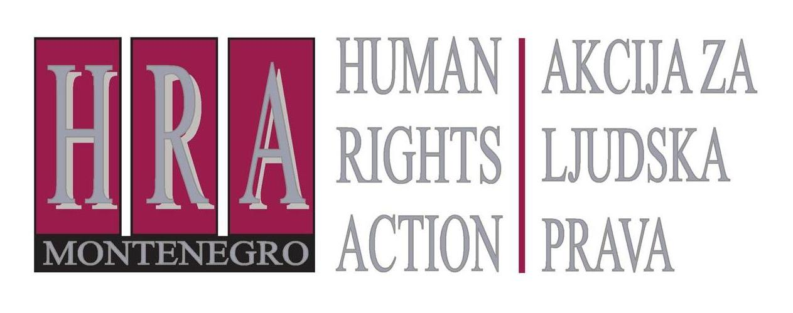

Ulica Slobode 74/ II, 81 000 Podgorica, Crna Gora T/F: +382 20 232 348/ +382 20 232 358; +382 20 232 122
E-mail: hra@t-com.me www.hraction.org

Presentation of the fourth report within the project
“Monitoring of Journalistic Self-Regulatory Bodies in Montenegro“

Podgorica, hotel Podgorica, 29 September 2014

Agenda

10:00 – 10:30 Registration of participants

10:30 – 10:44 Introductory remarks

Ms Tea Gorjanc Prelević, executive director of Human Rights Action

H.E. Ian Robert Whitting, Her Majesty's Ambassador

10:45 – 11:20 Presentation of the fourth report “Monitoring of Journalistic Self-Regulatory Bodies in Montenegro“

Dragoljub Duško Vuković, author of the report

11:20 – 13:00 Discussion

At the beginning of the discussion, the word will be given to the representatives of self-regulatory bodies in Montenegro, whose reports were subject of analysis in this HRA report, and afterwards, the word will be given to anyone who requests it, in the order of the requests.

The project ”Monitoring of Journalistic Self-Regulatory Bodies in Montenegro” has been supported by




