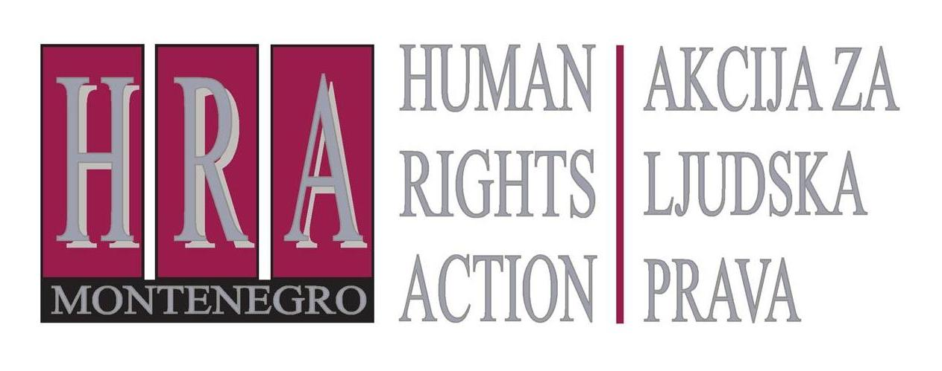
v

Bulevar Svetog Petra Cetinjskog 130/VII, 81 000 Podgorica, Crna Gora T/F: +382 20 232 348/ +382 20 232 358; +382 20 232 122
E-mail: hra@t-com.me www.hraction.org

PRESIDENT OF MONTENEGRO

Mr. Milo Djukanović

Podgorica, 22 July 2022

Esteemed President of Montenegro,

Mr. Djukanović,

I would like to take this opportunity to thank you for the proposal you addressed to the Prime Minister, Mr. Abazović – namely, that I join, as a representative of Human Rights Action, the expert team which would examine the conformity of the provisions of the Basic Agreement of Montenegro with the Serbian Orthodox Church, adopted by the Government of Montenegro at the session held on 8 July of this year, with the legal order of Montenegro.

Although I did express my willingness to participate in the work of such a team, since you convinced me that, according to your knowledge, there is a possibility that the Government might change the adopted conclusion, I now feel obliged not to take advantage of the offered opportunity.

It is now 10:35 a.m., and I just received an invitation from the Prime Minister's office to appear at the meeting of the expert team at 2 p.m. today. Mrs. Ivona Jovanović confirmed that the Prime Minister has included in the team the attorney Velibor Marković, who is known for his public promotion of homophobia and sexism, that is, his intolerance towards the LGBTIQ community and women, specifically female judges. I have attached to this communication some of his public announcements, in which he threatened to “break the spines” and “twist the necks” of LGBTIQ persons, whom he considers deviant, addressed female judges in a vulgar manner, accusing them of drafting judgments in line with their current psycho-physical conditions, which are female characteristics.

Acting upon reports of our male and female colleagues from the organisations LGBT Forum Progress and LGBTIQ Social Centre, the Protector of Human Rights and Freedoms of Montenegro issued the Opinion no. 604/20 of 24 November 2020, in which it was concluded that attorney Marković’s announcements constituted hate speech, i.e. a gross form of discrimination, and, among other things, recommended that he “issue a public apology to members of the LGBTIQ population and advocates of their rights”, which he refused to do.

Despite several urgencies, the Bar Association of Montenegro, unfortunately, failed to act on the report our colleagues from the organisation Centre for Women’s Rights filed against attorney Marković after he violated the Code of Professional Ethics of Attorneys by making the above announcements on 27 July 2020. The report was supported by several non-governmental organisations involved with the coalition Together for LGBT Rights, including the Human Rights Action. Had the Bar Association dealt with the views of attorney Marković, and protected the reputation of attorneys and the general legal culture in Montenegro, perhaps we would not be in this situation we currently are in.

All in all, I protest the inclusion of attorney Marković in the work of a public group that is supposed to contribute to the public interest. Common good cannot be built on the denial of rights to, and the humiliation of, any people in a society, including the LGBTIQ community and women. Neither I nor anyone else from the Human Rights Action is willing to cooperate with a person who promotes discrimination and hatred. I will therefore not be participating in the work of the expert team, nor can I recommend a replacement from the organisation I represent.

Regardless of the above, we will expand the opinion on the Basic Agreement between Montenegro and the Serbian Orthodox Church that was submitted earlier by the Human Rights Action, by including new sources and enriching it with arguments, in view of the publicly stated positions that contested it. We will also provide suggestions so as to enable the disputed provisions to be formulated in a way that will harmonise them with the legal order. We will submit them to you and the Prime Minister in writing, and publish them on our Internet presentation.

I would like to take this opportunity to express my hope that the good intention - of harmonising the Agreement with the legal order - will be realised, for the common good.

Respectfully yours,

Tea Gorjanc Prelević
Executive Director, NGO Human Rights Action

