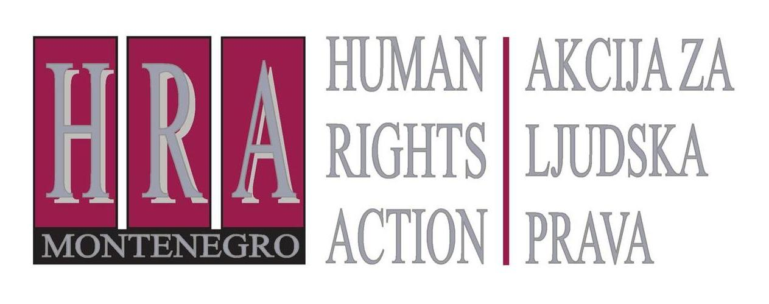

Slobode 74/ II, 81 000 Podgorica, Montenegro T/F: +382 20 232 348/ +382 20 232 358; +382 20 232 122
E-mail: hra@t-com.me www.hraction.org

Regarding the text published today, on 17 November 2015, by daily Dnevne novine on their front page and pages 2 and 3, entitled „How Tea and Sonja 'are tailoring' Montenegrin judiciary“, with a headline EXCLUSIVE: CORRESPONDENCE BETWEEN SONJA DIEZ FROM THE EUROPEAN COMISSION AND TEA GORJANC PRELEVIĆ, and announcement on the front page “correspondence between Tea and Sonja is a true scandal raising many questions both for the national institutions and the European Commission that must not remain unanswered“
I hereby reply the following:
- Unauthorised publication of my correspondence with Ms Sonja Diez from the European Commission, apart from being problematic from the aspect of morality and journalistic ethics, constitutes a criminal offence of Violation of Privacy of Correspondence and Other Communication from Article 172 of the Criminal Code of Montenegro.

- Daily Dnevne novine published this private correspondence incompletely and falsified the part relating to Ms Sonja Diez. The falsified part is reflected in one part of her response to me at the beginning of the text, “hopefully Luca will side with us”, which was not written by Ms Diez. In our correspondence, Ms Diez from the European Commission (EC) has not announced any other position except that she hoped that by-laws to the Law on the Judicial Council would be of good quality. In addition, Ms Diez has informed me about the position of the Judicial Council on the application of the law in the case of election of the President of the Administrative Court and asked for my comment. HRA received the same incomplete position directly from the Judicial Council.

- All positions that I, in my capacity of a human rights activist, announced in private correspondence with Ms Sonja Diez had previously been published in press releases and public statements of Human Rights Action (HRA), and therefore present neither news nor a scandal, as presented by daily Dnevne novine, in an obvious attempt to discredit both HRA and the EC.

- HRA criticism of the Judicial Council’s operation is widely known. HRA positions about the suspicious decisions of the Judicial Council on the election of judges, which in the case of the election of the President of the Administrative Court even appear unlawful, were announced also to the President of the Judicial Council and repeated recently at the public presentation of the EC’s Montenegro 2015 Report. Positions from the correspondence published by daily Dnevne novine have been supplemented in the meantime by additional criticism of the Judicial Council operation, of which we also informed the public in detail. We will once again draw attention of the MPs to our concerns regarding the biased operation of the Judicial Council, because they will soon have to discuss in the Parliament the Report on the work of the Judicial Council for 2014.

- HRA position on the election of Ms Branka Lakočević as President of the Administrative Court is also widely known. Although she has never been a judge, Ms Lakočević has been, quite unconvincingly, evaluated better than other two competing judges of the Administrative Court, although previous work of the candidate in the capacity of a judge had to be evaluated during election process. To avoid misunderstandings, expertise and the indisputable experience of Ms Lakočević, which could have recommended her for another office (as Minister of Justice or President of the Constitutional Court) is not being called into question, but the failure to comply with the rules in the work of the Judicial Council electing her as the president of the Administrative court is.

- In response to the question of daily Dnevne novine about what Ms Šofranac [editor-in-chief of this newspaper] maliciously labelled as "the best part" of the correspondence, when I wrote that I hoped Mr. Luca Perilli ( independent expert of an EU Member State for secondary legislation) would “side with us”, I explained that by this I meant the position of Perilli, with which HRA already publicly disagreed, that laws in Montenegro in relation to the appointment of judges and prosecutors should not be very detailed, but should instead give some room for discretion to those who decide on these elections. I believe that every government - as "the official side" always welcomes additional room for manoeuvre, unlike our - activist "side" - which has been insisting on preventing such possibilities for a long time by adopting precise indicators for evaluation of candidates for the first election of judges and especially for their promotion. I would have explained this all to daily Dnevne novine had they not rushed so much with publishing my private correspondence, in which I have not been obliged to explain anything in detail to anyone.

I still hope that our "side" will win, and that Mr Perilli will strive to make the indicators for the evaluation criteria for the election of judges and prosecutors more detailed and precise. I have nothing else to fight for here, except for the public interest through protection of impartial promotions in the judiciary.

- HRA, just like many other NGOs in Montenegro and the region, has been openly communicating and cooperating for years with the EC employees, foreign diplomats and representatives of international organizations such as the UN, Council of Europe and the OSCE, on the topic of judicial reform and acceptance of international human rights standards. The fact that daily Dnevne novine finds conversations of NGOs with organisations of which Montenegro is a member, or whose member it strives to become, suspicious and scandalous, just shows that they obviously remain locked in some old-fashioned spy movie.

- Due to the malicious attempts of daily Dnevne novine to present this whole situation as an international scandal by making absurd commentaries – I made my entire correspondence on this occasion available to the public from today on HRA website www.hraction.org.

Tea Gorjanc-Prelević
HRA executive director

The original in Montenegrin: “Kako Tea i Sonja 'kroje' crnogorsko pravosuđe“
The original in Montenegrin: „EKSKLUZIVNO: PREPISKA SONJE DIEZ IZ EK I TEE GORJANC-PRELEVIĆ“
The original in Montenegrin: ”Korespondencija Tee i Sonje je pravi skandal koji otvara mnoga pitanja i za domaće institucije i Evropsku komisiju koja ne smiju ostati bez odgovora”

