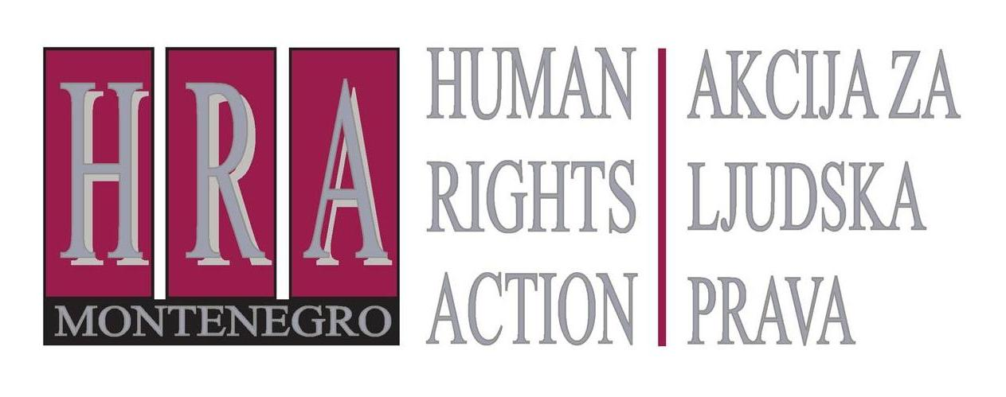

Ulica Slobode 74/ II, 81 000 Podgorica, Crna Gora T/F: +382 20 232 348/ +382 20 232 358; +382 20 232 122
E-mail: hra@t-com.me www.hraction.org

MINISTRY OF TRANSPORT AND MARITIME AFFAIRS
Mr Osman Nurković, Minister

Podgorica, 30 March 2017

Subject: Verbal assault and threats against Milisav Dragojević and his family

Honorable Minister Nurković,

I am writing in order to kindly ask you to protect Mr. Milisav Dragojević, an employee of the Railway Transport, director of the NGO Center for railway research, against threats and attacks and provide immediate and impartial examination of his claims on breach of regulations that endangers the safety of the railway traffic.

In August 2016 the Anti-Corruption Agency provided whistleblower status to Mr Dragojević. Previously, against him the disciplinary proceeding was unfounded conducted, because he publicly alleged about the violation of the procedure for obtaining permission for operating trains and on Monday, 27 March 2017, the manager of the transportation operations of the Railway transport Ilija Lubarda threatened him.

As Dragojević informed us, the motive for threats to him and his family this time was a statement he gave at the morning show on the RTCG, "that train drivers involved in traffic safety and on which depends the safety of passengers, take professional exams before unprofessional and incompetent commissions, composed of individuals who did not pass the professional exam for engineering towing in the prescribed manner and who do not have the necessary knowledge and practice on the work of train drivers, so none should be surprised by omissions of young engine drivers while driving passengers. "

We kindly ask you to, in accordance with your responsibilities, urgently examine the accuracy of Dragojević's allegations about incompetence of membership of the commission before whom train drivers take professional examinations and inform the public about the results, as well as to protect him from future threats and attacks.

Yours sincerely,

____________________
Tea Gorjanc Prelević
HRA executive director

